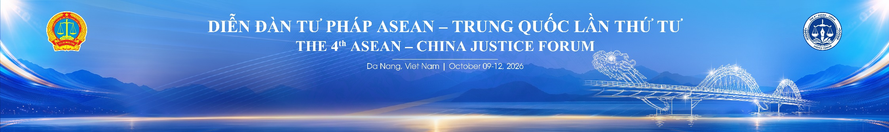
HOME | TENTATIVE PROGRAMME | MEETING ROOM LAYOUT | Da Nang Sightseeing Tour
INTRODUCTION
VENUE

I. HOME
1. INTRODUCTION
4th ASEAN–China Justice Forum

Hosted by
Supreme People's Court of the Socialist Republic of Viet Nam

The 4th ASEAN–China Justice Forum is convened to further strengthen and deepen bilateral and multilateral judicial cooperation between the People's Courts of ASEAN Member States and the Supreme People's Court of the People's Republic of China. The Forum also contributes to advancing the ASEAN–China Comprehensive Strategic Partnership, promoting regional economic integration, and supporting the implementation of the policies of the Communist Party of Viet Nam and the State of Viet Nam on enhancing international integration in the field of justice.
The Forum serves as a high-level platform for judicial authorities to exchange views, share best practices and practical experiences on judicial reform, the adjudication of cross-border civil, commercial and criminal cases, as well as the development of e-Courts and the application of digital technologies and Artificial Intelligence (AI) in judicial proceedings.
The Forum also aims to reinforce the standing and role of the Supreme People's Court of Viet Nam within the ASEAN region and the international judicial community.
The theme of the Forum is:
"Strengthening Regional Judicial Cooperation in the Context of International Integration and the Digital Era."
The Forum will focus on the following two substantive sessions:
- Cross-border Cooperation in Criminal Justice and the Resolution of Civil and Commercial Disputes in the Digital Era;
- Sharing Experiences in the Development of e-Courts and the Application of Artificial Intelligence (AI) in Judicial Assistance and Future Prospects.

The Forum is hosted by the Supreme People's Court of the Socialist Republic of Viet Nam and will be held from 9–12 October 2026 at Furama Resort Danang, Da Nang City, Viet Nam.

2. VENUE
Welcome distinguished delegates to the 4th ASEAN–China Justice Forum, which will be held in Da Nang, one of Viet Nam’s leading coastal cities known for its modern infrastructure and vibrant tourism environment. The venue is Furama Resort Danang, a premier beachfront resort offering world-class facilities and services.
- Date: 9–12 October 2026
- Venue: Furama Resort Danang
105 Vo Nguyen Giap Street, Ngu Hanh Son District, Da Nang City, Viet Nam.
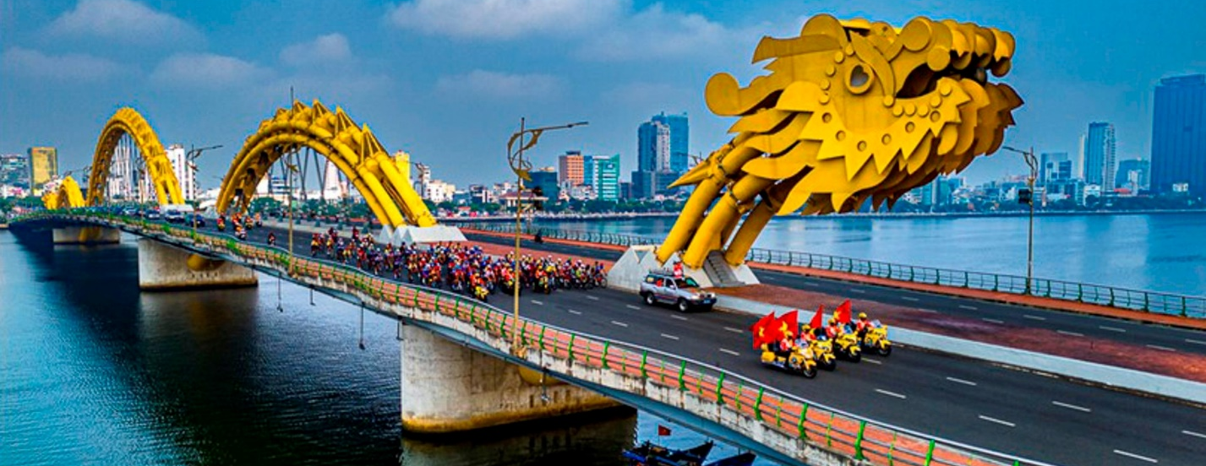

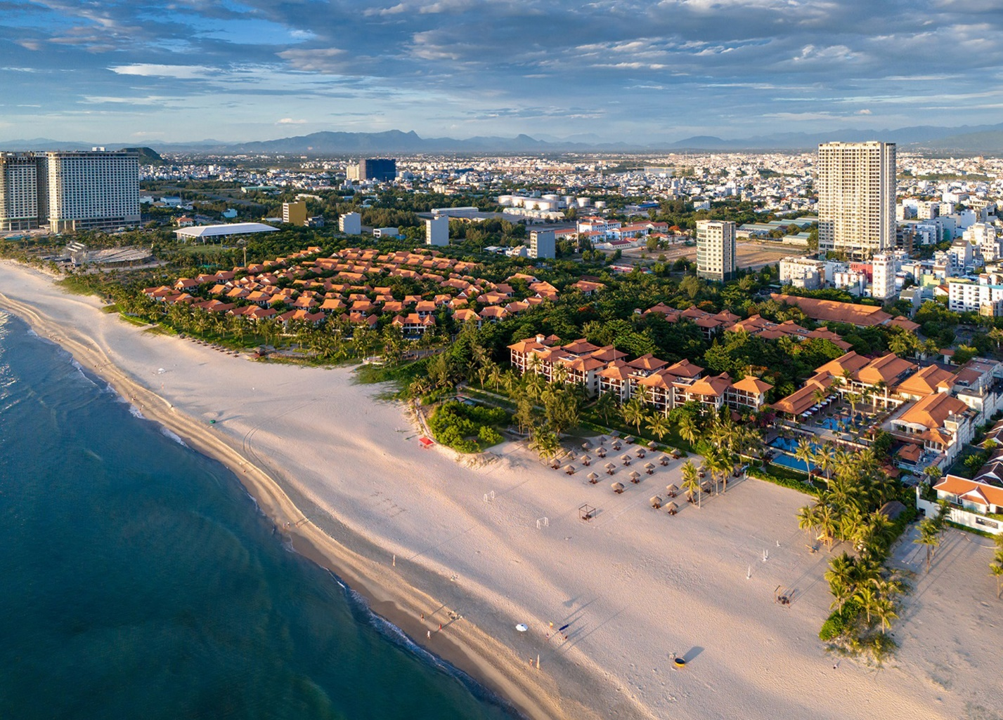

II. TENTATIVE PROGRAMME

Friday, 9 October 2026
TIME | ACTIVITY | REMARKS
All day | ARRIVAL AND RECEPTION OF DELEGATES

Saturday, 10 October 2026
TIME | ACTIVITY | REMARKS
DIỄN ĐÀN TƯ PHÁP ASEAN – TRUNG QUỐC LẦN THỨ TƯ
The 4th ASEAN–China Justice Forum
Forum on “STRENGTHENING REGIONAL JUDICIAL COOPERATION IN THE CONTEXT OF INTERNATIONAL INTEGRATION AND THE DIGITAL ERA”
OPENING CEREMONY
08:00 – 08:30 | Delegate Registration | Organizing Committee
08:30 – 08:40 | Statement of Purpose and Introduction of Delegates | Supreme People’s Court of Viet Nam
08:40 – 08:55 | Opening Remarks by the Chief Justice of the Supreme People’s Court of Viet Nam | Mr. Nguyen Van Quang, Chief Justice of the Supreme People’s Court of Viet Nam
08:55 – 09:10 | Remarks by the Chief Justice of the Supreme People’s Court of China | Mr. Zhang Jun, Chief Justice of the Supreme People’s Court of China
09:10 – 09:20 | Welcome Remarks by a Leader of the Party and State
09:20 – 09:30 | Welcome Remarks by the Secretary of the Da Nang City Party Committee
09:30 – 09:45 | Group Photo
09:45 – 09:55 | Coffee Break
SESSION I
TOPIC 1: “COOPERATION IN THE RESOLUTION OF CROSS-BORDER CRIMINAL CASES AND CIVIL AND COMMERCIAL DISPUTES IN THE CONTEXT OF THE DIGITAL ERA”
Chair: Deputy Chief Justice of the Supreme People’s Court of Viet Nam
09:55 – 10:00 | Introductory Remarks | Supreme People’s Court of Viet Nam
10:00 – 10:15 | Presentation by Viet Nam | Representative of the Supreme People’s Court of Viet Nam
10:15 – 10:45 | Presentations by China | • Judge ZHU Yu, Chief Justice of the High People’s Court of Hunan Province  • Judge HUANG Hailong, Chief Justice of the High People’s Court of the Guangxi Zhuang Autonomous Region (15 minutes per Judge)
10:45 – 11:00 | Presentation by Brunei Darussalam | H.E. Mohammad Marzuqi Bin Sabtu, Registrar, Supreme Court of Brunei Darussalam; Judge Abdul ’Azim Bin Othman
11:00 – 11:15 | Presentation by Cambodia | Ms. Chaing Sinath, Deputy Chief Justice of the Supreme Court of Cambodia
11:15 – 11:30 | Presentation by Indonesia | Mr. Prim Haryadi, Director of the Criminal Division, Supreme Court of Indonesia
11:30 – 11:45 | Presentation by Lao PDR | Deputy Chief Justice of the Supreme People’s Court, Bounkhouang Thavisack
11:45 – 12:00 | Presentation by Myanmar | Mr. Zar Li San, Assistant Director, Department of International Cooperation and Judicial Administration, Supreme Court of Myanmar
12:00 – 12:15 | Presentation by Timor-Leste | H.E. Afonso Carnara, Chief Justice of the Supreme Court of Timor-Leste
12:15 – 12:30 | Summary of Session I | Representative of the Supreme People’s Court of Viet Nam
12:30 – 13:50 | Lunch Break
SESSION II
TOPIC 2: “SHARING EXPERIENCES IN DEVELOPING ELECTRONIC COURTS AND APPLYING ARTIFICIAL INTELLIGENCE (AI) TO SUPPORT ADJUDICATION, AND FUTURE PROSPECTS”
Chair: Judge Jia Yu, Chief Justice of the High People’s Court of Shanghai Municipality
13:50 – 14:00 | Settling of Delegates | Organizing Committee
14:00 – 14:05 | Introductory Remarks | Representative of the Supreme People’s Court of China
14:05 – 14:20 | Presentation by Viet Nam | Representative of the Supreme People’s Court of Viet Nam
14:20 – 14:50 | Presentations by China | • Judge JIA Yu, Chief Justice of the High People’s Court of Shanghai Municipality  • Judge ZHANG Haibo, Chief Justice of the High People’s Court of Guangdong Province (15 minutes per Judge)
14:50 – 15:05 | Presentation by Indonesia | H.E. Suharto, Deputy Chief Justice of the Supreme Court of Indonesia
15:05 – 15:20 | Presentation by the Philippines | H.E. Atty. Michael Navallo, Lawyer, Chief of the Public Information Office of the Supreme Court of the Philippines
15:20 – 15:35 | Presentation by Singapore | Mr. Pang Khang Chau, Judge of the Supreme Court of Singapore
15:35 – 15:50 | Summary of Session II | Representative of the Supreme People’s Court of China
15:50 – 16:10 | Break
16:10 – 16:20 | Presentation of the Draft Da Nang 2026 Joint Communiqué | Supreme People’s Court of Viet Nam
16:20 – 16:30 | Discussion and Adoption of the Joint Communiqué | Delegates
CLOSING CEREMONY
16:30 – 16:45 | Closing Remarks by the Chief Justice of the Supreme People’s Court of China | Mr. Zhang Jun, Chief Justice of the Supreme People’s Court of China
16:45 – 17:00 | Closing Remarks by the Chief Justice of the Supreme People’s Court of Viet Nam | Mr. Nguyen Van Quang, Chief Justice of the Supreme People’s Court of Viet Nam
GALA DINNER
18:30 – 21:00 | Reception Hosted by the Chief Justice of the Supreme People’s Court of Viet Nam
Sunday, 11 October 2026
Time | Activity | Remarks
09:00 – 15:30 | Ba Na Hills Sightseeing Programme for International Delegates
15:30 | Delegations return to their hotels for rest and preparation for the evening reception. The Chinese Supreme People’s Court Delegation will pay a courtesy call on the Secretary of the Da Nang City Party Committee and visit the People’s Court of Da Nang City.
15:30 – 16:15 | Transfer from Ba Na Hills to the Da Nang City Party Committee Headquarters
16:15 – 17:00 | Courtesy Call on the Secretary of the Da Nang City Party Committee
17:00 – 17:15 | Transfer to the People’s Court of Da Nang City
17:15 – 18:00 | Visit to the People’s Court of Da Nang City
DINNER RECEPTION
19:00 – 21:00 | Reception Hosted by the Leaders of Da Nang City
Monday, 12 October 2026
Time | Activity | Remarks
All day | Departure of International Delegations

III. MEETING ROOM LAYOUT

